Get Accept Document :
Here I Give Permission to My User to Access GetAccept Admin.
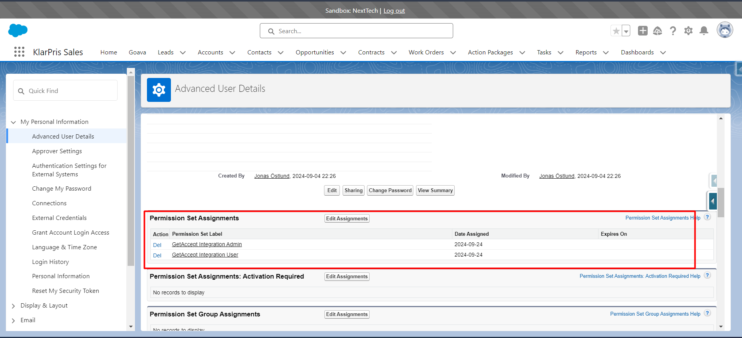
And Create a Pricing Table Using Production Org.
Link: https://hantverksdataab--nexttech.sandbox.lightning.force.com/lightning/n/GetAccept__Setup
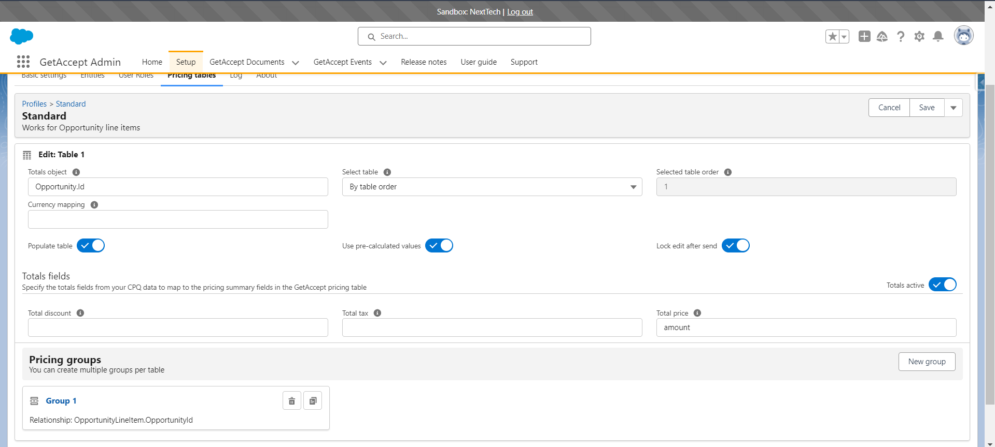
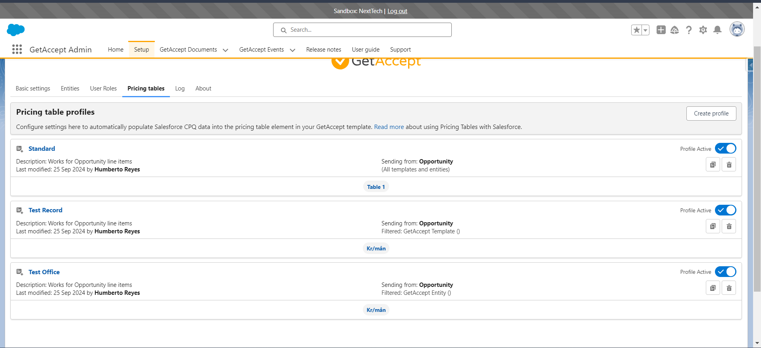

Questions:-
- I don’t know how to create a document to use and create a template With the pricing table in GetAccept Using Salesforce Org.
- How can use that document in salesforce to send to the client.

